**CMPE 297 – Special Topics in Software Engineering**

**FALL 2017**



**IOS Application Development**

**Assignment 1 - IOS Data Storage Assignment**

**Submitted by- Submitted to-**

Anvit Saxena Prof. Chandrashekhar

SJSU ID: 010953436

1. Used Xcode to create a new project. Used Objective-C as the language to develop iOS application. Created UI storyboard as below:

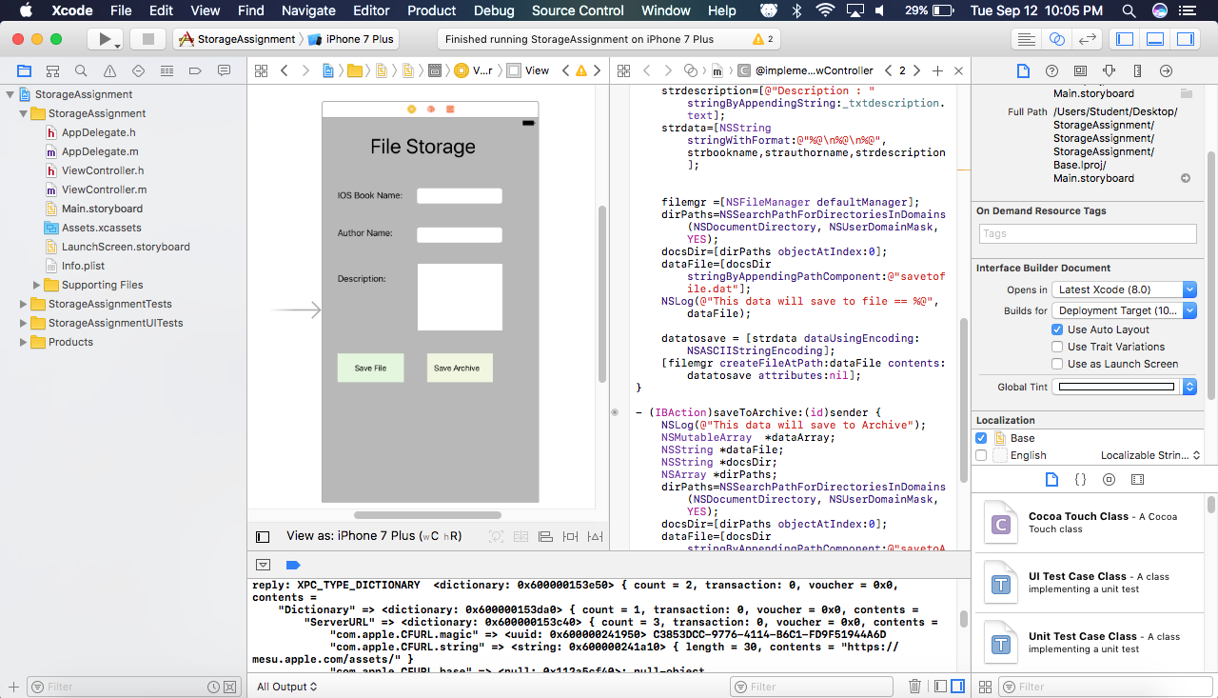

1. Developed the app and used inbuilt emulator to run the application.

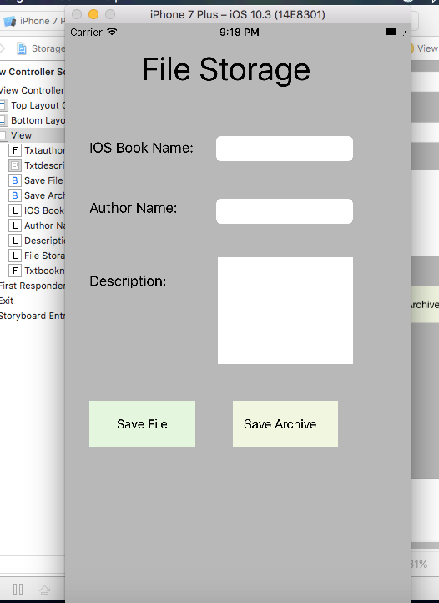

1. Entered the details in the application and clicked on Save File and Save Archive.

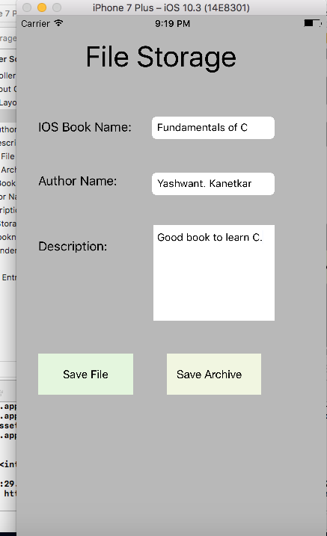

1. The file and the archive file is saved in the below location after clicking on Save button from the application.

**/Users/Student/Library/Developer/CoreSimulator/Devices/214E6A34-1703-4D24-B61E-14337D4A70FA/data/Containers/Data/Application/23C93A38-167E-40E8-BBF5-8700AA19D6D9/Documents/savetoArchive.dat**

**/Users/Student/Library/Developer/CoreSimulator/Devices/214E6A34-1703-4D24-B61E-14337D4A70FA/data/Containers/Data/Application/23C93A38-167E-40E8-BBF5-8700AA19D6D9/Documents/savetofile.dat**

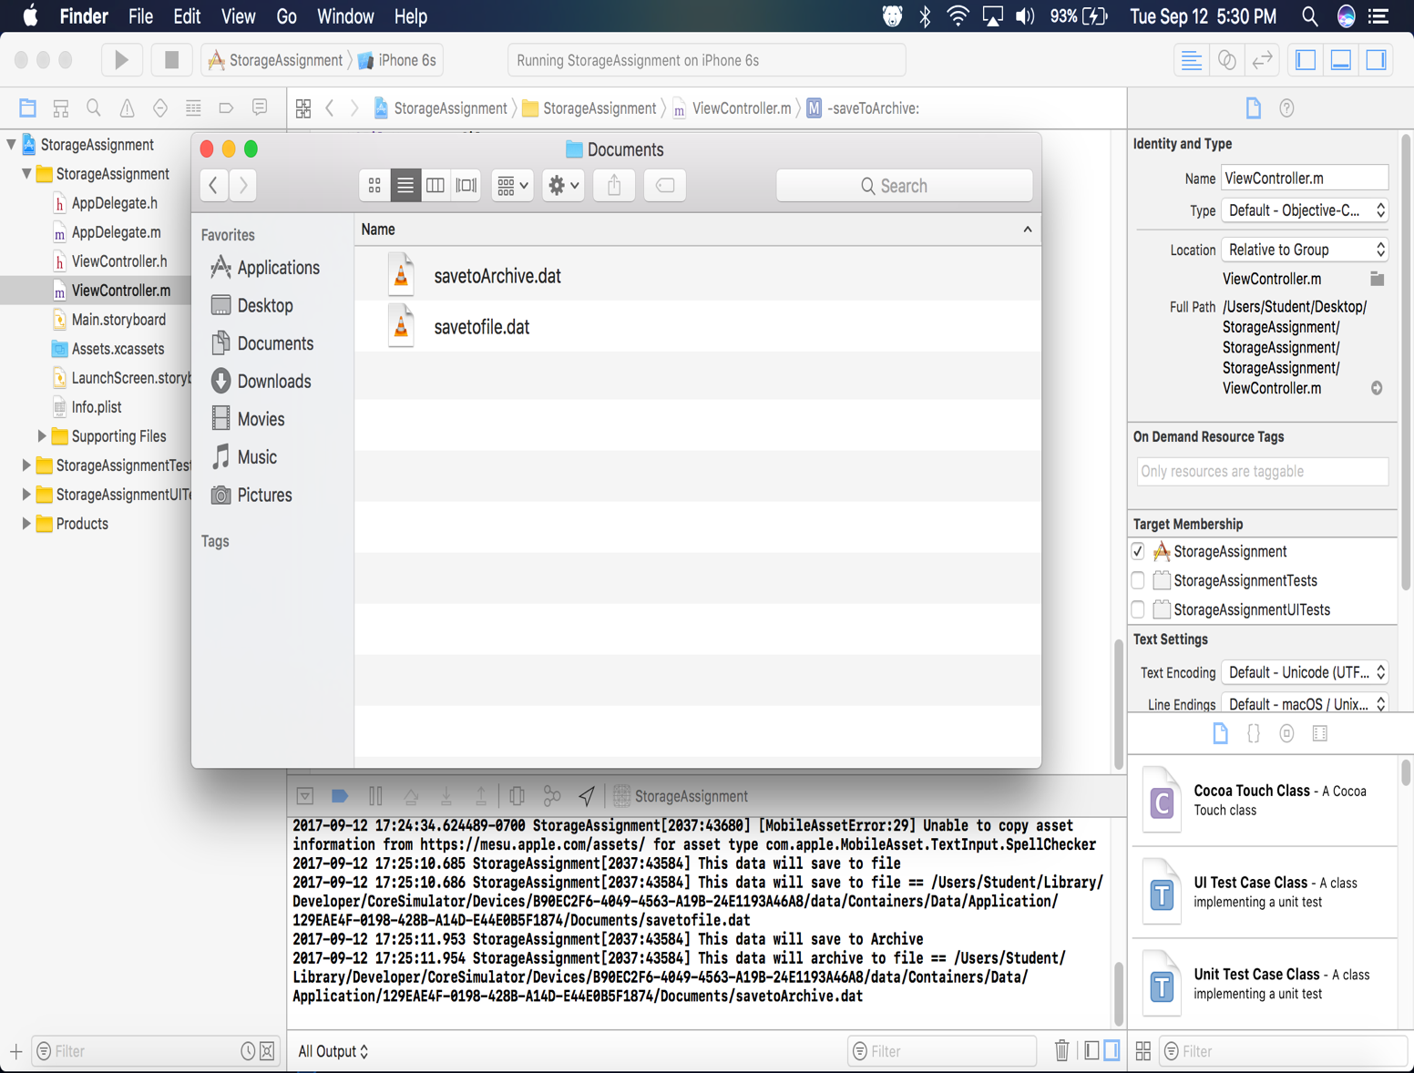

1. We can also see the output by opening the file. The same details which we entered in our application will be shown in the saveToFile.dat file as shown below:

